Short & Snappy Troop Financials 101

Each year Troops/Service Units are required to submit an Annual Troop/Service Unit Financial Report. Scanned copies of all receipts, corresponding bank statements, as well as the Financial Report need to be emailed to customercare@girlscoutsccs.org. Troops/Service Units carrying over $300 at the end of the year must document plans on the report for spending the funds. It is normal for a Troop after the Product Program to have a large amount of money. We need this information for auditing purposes. Service Unit Treasurers, Council staff, and/or the Council’s audit firm audits these reports.

Protect yourself! Money is one of those areas that can cause a lot of bad feelings and ill will among girls and parents in a Troop/group if people suspect wrongdoing. Save yourself an endless amount of heartache and avoid the possibility of having your financial practices being called into question by following these best practices:

- Keep good financial records, including receipts for all expenditures
- Involve girls (and sometimes parents) in financial decision-making

- Report on the Troop/Service Unit finances regularly (monthly) to girls and families

- Update the detailed financial report monthly so all transactions are transparent when you are asked

You will need the following items before completing the Financial Report:
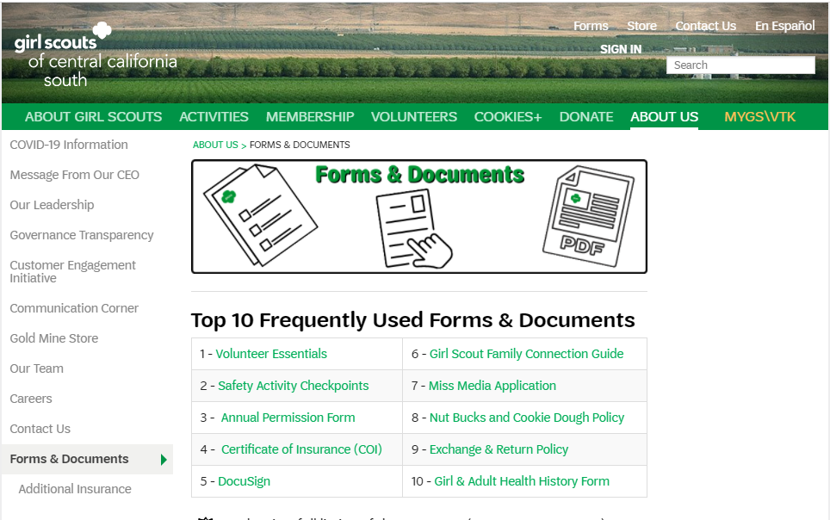
- Annual Financial Worksheets (includes Detailed Cash Record for Troop/Service Unit and Annual Troop/Service Unit Financial Report and Inventory) Located on the Forms page under About Us Tab at www.girlscoutsccs.org.

- The Annual Financial Worksheets are formatted as an Excel workbook, with two separate worksheets. You can toggle between the two worksheets by using the sheet tabs at the bottom left of the workbook.
  - All twelve bank statements for June 2021 to May 2022
  - All receipts for purchases from June 2021 to May 2022
  - All deposit receipts from June 2021 to May 2022
  - Ending balance as of May 2021

Detailed Cash Record for Troop/Service Unit
- Download the Annual Financial Worksheets from the Forms Tab in the About Us Tab of the website. The automated Excel workbook tallies the columns and rows of the record automatically, and transfers the information from the Detailed Cash Record to the Annual Troop/Service Unit Financial Report – saving you time.

Detailed Cash Record is pictured below:
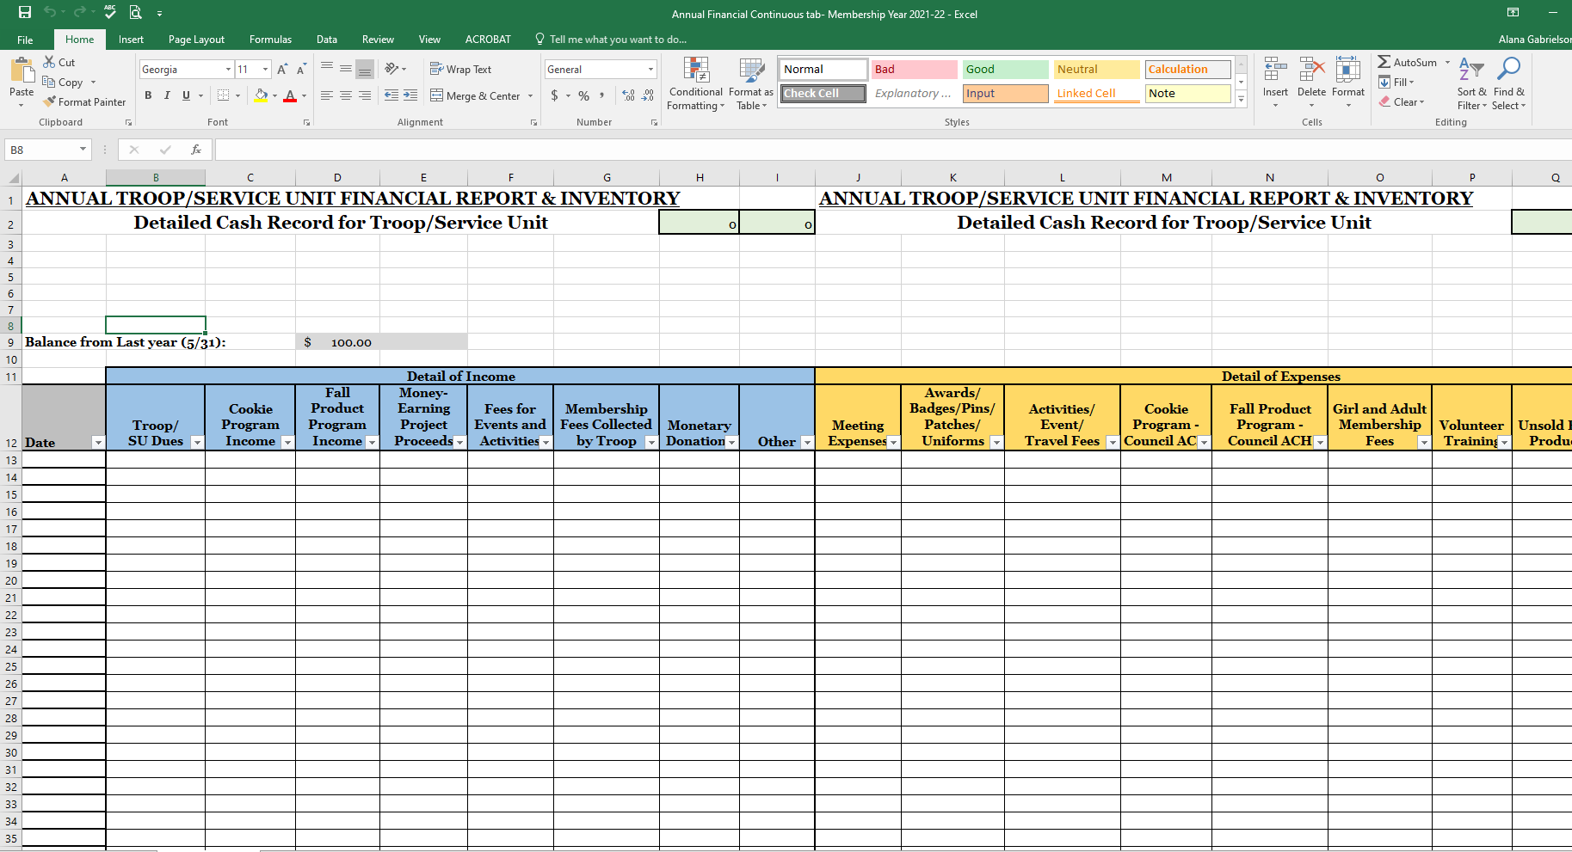

Instructions on Completing the Detailed Cash Record

- First, complete the Detailed Cash Record Tab.
Add the Balance from last year (5/31) field. Use the bank statement for May 31st of last year or last year’s Annual Troop/Service Unit Financial Report (they should match) to insert the balance from last year (5/31.)

- Begin completing the rows by inserting the following data in each column:

- Date – use date of check, receipt or deposit.
- Detail of income – if deposit, put the amount of money received for each category from the deposit in the corresponding column (Troop Dues, Cookie Program Income, Fall Product Program Income, Money Earning Projects, Fees for events and activities, Membership fees collected by Troop, Monetary donations, or other.) Note: Deposit all monies into the bank account. Reimburse all expenses through checks or debit card transactions. This gives a clean view of all transactions.
- Detail of Expense – if expenditure, put the amount of money spent for each category in the corresponding column (meeting expenses, awards/badges/etc., activities/event/travel fees, Cookie Program Council ACH, Fall Product Program Council ACH, Girl and Adult Membership Fees, Volunteer Training, Unsold Fall Product, Unsold Cookies, other.) Be sure to complete the itemized description of expense.
- Account Activity – The worksheet will automatically calculate the running balance.
- Repeat steps 1 through 3 for all deposits and expenditures from June 2021 to May 2022. Do not include expense or income that has not cleared on the bank statement for May. Hold all receipts until the following year if they have not cleared by May 31st.

Your totals will be automatically tallied from the detailed cash record into the Financial Report and Inventory Form. The ending Running Balance must match the ending bank balance on the May 31st bank statement.

Let’s review some of the basic categories used on the report forms:
- Troop Dues – collected from the girls for Troop activities and awards
- Cookie Program Income – collected during the Cookie Program from girls, parents, and booth customers

- Fall Product Program Income – collected during the Fall Product Program from girls, parents and booth customers

- Money Earning Projects – collected during fundraisers such as car wash, bake sale, yard sale, etc.

- Fees for Events and Activities – collected from Troop members for participating in events/activities/travel

- Membership Fees Collected by Troop – fees for membership collected from parents

- Monetary Donations – monetary donations made to Troop

- Meeting Expenses – purchases of craft supplies, photocopies, books, activity supplies, glue, markers, etc. for use at Girl Scout meetings/events.

- Awards/Badges/Pins/Patches/Uniforms – purchases of uniforms and awards for Troop members

- Activities/Event/Travel Fees – expenditures of Troop money for participation in activities or events (such as Service Unit events or Council events) and travel fees (trip expenses such as hotel, gas, food, etc.)

- Cookie Program-Council ACH – funds pulled by Council for Cookie Program

- Fall Product Program-Council ACH – funds pulled by Council for Fall Product Program Girl and Adult Membership Fees – membership fees paid out of Troop bank account Volunteer Training – fees for volunteer training paid by Troop
- Unsold Fall Product – monetary value of unsold Fall Product owned by Troop

- Unsold Cookies – monetary value of unsold cookies owned by Troop

- Other – any receipt or expenditure that does not fall into one of the listed categories, such as donations, bank interest or fees. Be sure to state an itemized description of expense or receipt on Detailed Cash Record form

Annual Troop/Service Unit Financial Report & Inventory form

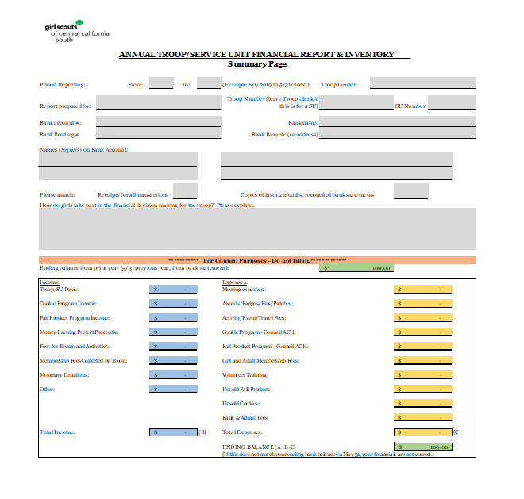

- Complete the Period Reporting From and To - June 1 to May 31.
- Information on who is completing the form.
- Add Troop or Service Unit number.
- Bank account information including account number, routing number, bank name and signers on the bank account.
- Ending Balance from previous report or zero if new Troop.
- Answer the question “How do the girls take part in the financial decision making for the Troop?”
- Totals section – automatically updated from Detailed Cash Record.
- Attach scanned copies of all twelve bank statements for the reporting period, scanned copies of all receipts, and the Annual Financial Worksheets. If missing a receipt: type a note stating the date of the transaction, the amount, store/location and reason for purchase.
- Submit your completed Annual Financial Report with attachments, to cusomtercare@girlscoutsccs.org.
- Congratulations! You’ve successfully completed the required financial reporting for your Troop or Service Unit.

