How to Register for Girl Scouts
** If you have questions about the registration process, or would like help completing registration over the phone, please contact Customer Care at customercare@girlscoutsccs.org, or (800) 490-8653.

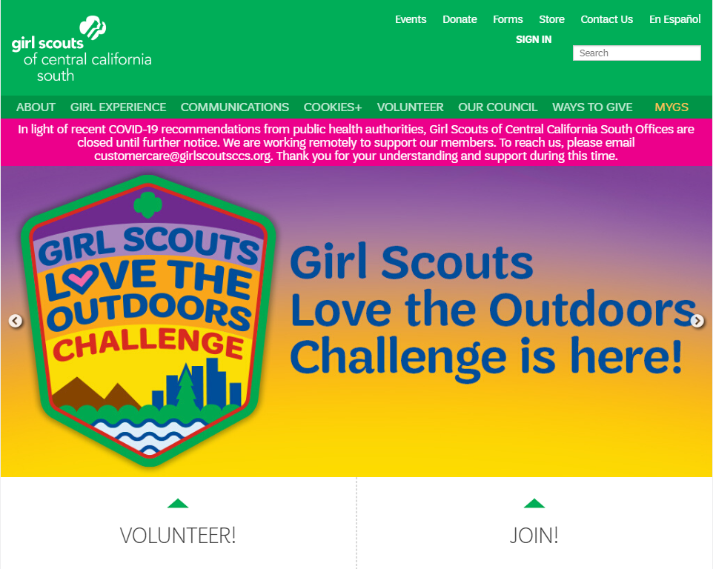
Step 1: Go to our website at www.girlscoutsccs.org and click “Join”.

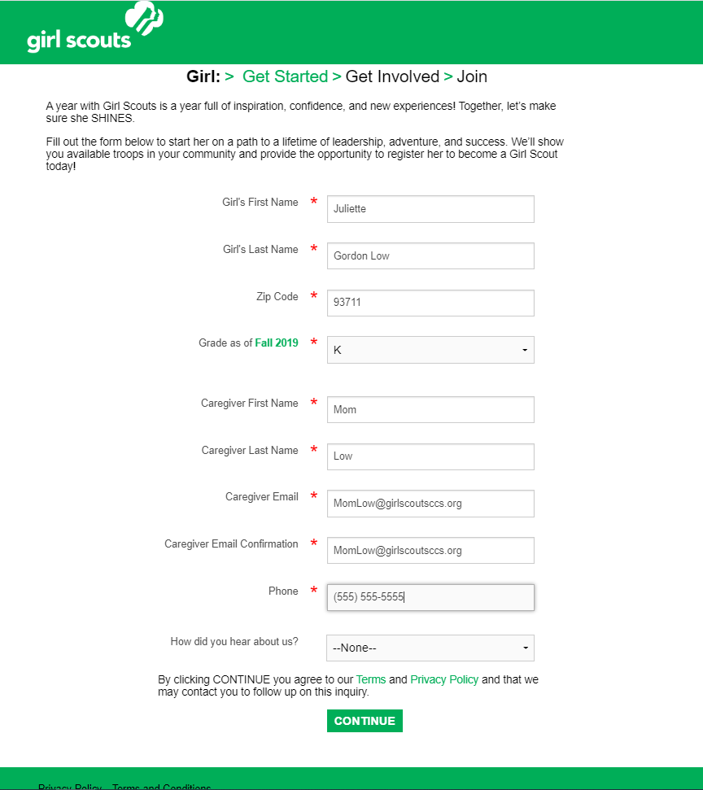
Step 2: Complete the “Get Started” page by filling in your Girl Scout’s contact information.

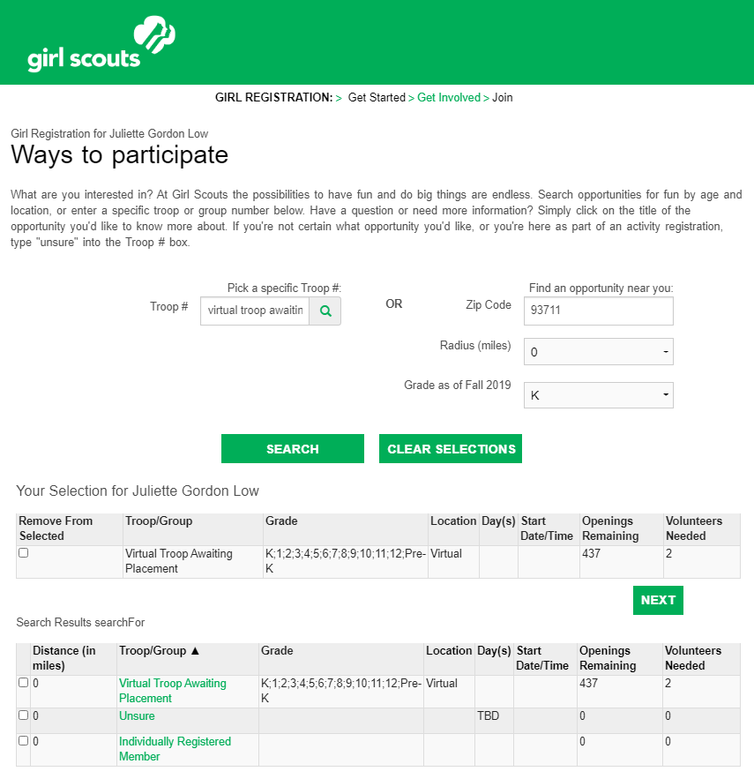
Step 3: Find your troop by searching for “Virtual Troop Awaiting Placement”. Select the check box next to “Virtual Troop Awaiting Placement”. Then click “Next”.

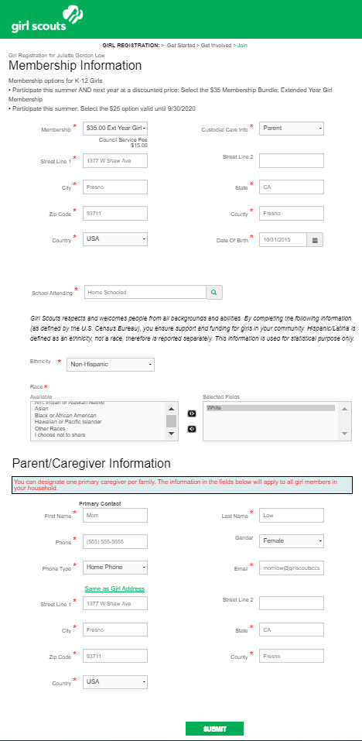
Step 4: Complete the “Membership Information” page by filling in your Girl Scout’s address, demographic, and school information. ** Note: Be sure to choose “$35 Extended Year Girl Membership”. You will not be charged for membership.

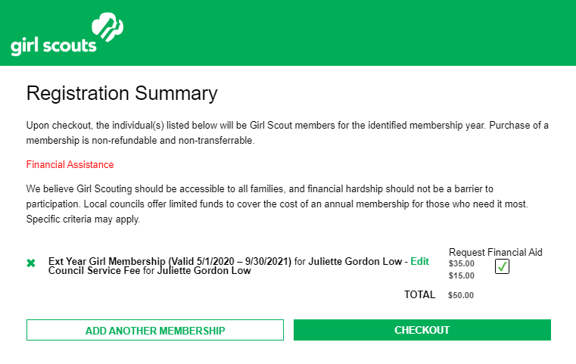
Step 5: Request “Financial Aid” on the Registration Summary Page. This will allow the council to register your Girl Scout at no cost to you. Then choose “Check Out”. A box will appear asking if you are sure you’d like to request financial aid. Click “Yes”.

Step 6: Accept the Girl Scout Promise and Law.
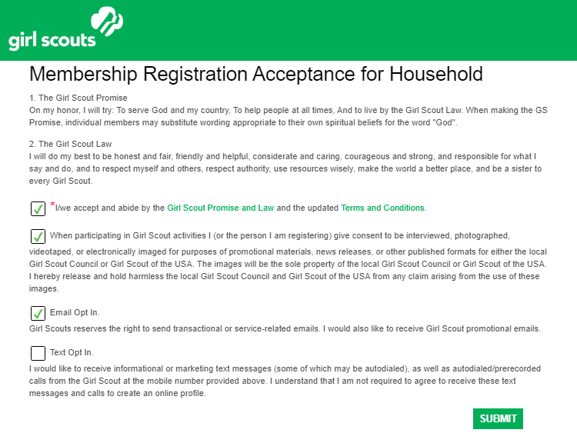
Step 7: Click “Continue” on the Order Summary Page.
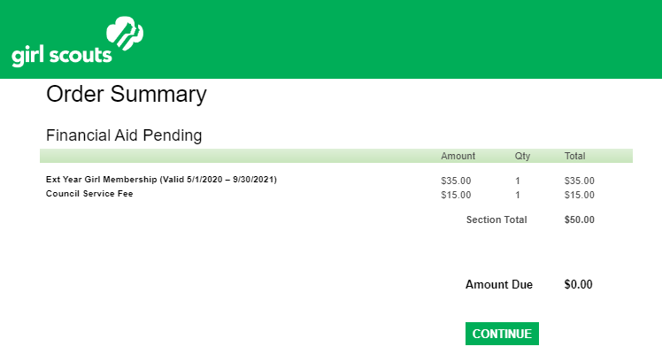
Step 8: Your Girl Scout is registered! Save you confirmation, and head over to the Events page on our website to sign your Girl Scout up for great virtual opportunities! https://www.girlscoutsccs.org/en/programs/event-list.html
