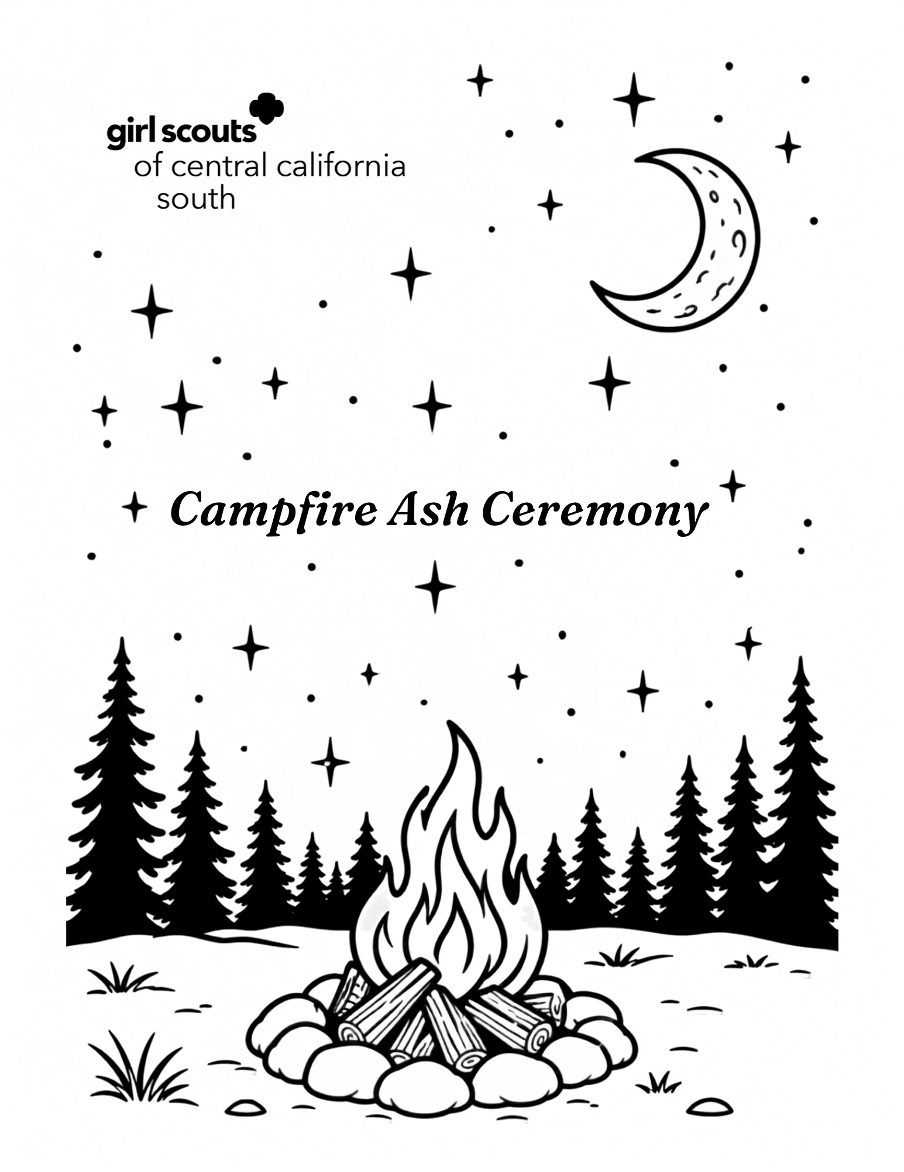

The Campfire Ash Ceremony
Campfire and ceremonies are among the most treasured traditions in Girl Scouting. When the two come together, they create one of the most meaningful experiences in the outdoors: the Campfire Ash Ceremony.

The Ash Ceremony is a long-standing tradition practiced by many Girl Scouts and Girl Guides around the world. This ceremony has been lovingly passed from one generation to the next for well over a century. Through this tradition, girls celebrate the worldwide sisterhood of Girl Scouting and the enduring legacy that connects every member across time and distance.

At the close of a campfire, a small amount of cooled ash is carefully saved. At a future campfire, those ashes are sprinkled into the new flames, symbolizing that the spirit, friendships, and memories of past campfire continue to live on. When that fire has burned down and the ashes have cooled, each participant may take a small pinch to carry to another campfire, continuing the tradition. Over the years, these ashes travel from camp to camp, state to state, and even country to country, creating a symbolic link among Girl Scouts and Girl Guides around the globe.

Many Girl Scouts also keep a record of the campfire where they have shared their ashes. As different troops gather, their campfire histories are combined, creating a living timeline of adventures, friendships, and shared experiences. It is a reminder that every campfire becomes part of a much larger story - one that stretches back more than 100 years and continues with each new generation.

The Ash Ceremony reminds us that no Girl Scout stands alone. Whether gathered around a fire in a neighborhood park, at summer camp, or on another continent, we are united by the same Promise and Law, the same love of the outdoors, and the same spirit of service and sisterhood. Each campfire becomes another link in an unbroken chain connecting Girl Scouts and Girl Guides around the world.
A traditional blessing, often called the Charge of the Ashes, is sometimes shared during the ceremony:
May the spirits of past campfires be here with us tonight, carrying fellowship in these ashes from other campfires, thus uniting us with friends and comrades in other lands. May the joining of the dead fires with the leaping flames of our campfire tonight symbolize once more the unbroken chain that binds Girl Guides and Girl Scouts around the world. Fond greetings to Girl Guides and Girl Scouts of all nations, everywhere.

As you take part in this ceremony, remember that you are adding your own chapter to a tradition that has inspired generations of Girl Scouts. The ashes you receive can only be carried by those who were present at the campfire, making each ceremony a unique and personal connection to the worldwide sisterhood. Wherever your journey leads, may the spirit of Girl Scouting travel with you - and may the light of this campfire continue to shine in every that follows.

International Campfire Ashes
“We carry our fellowship with us in these ashes from other campfires with other friends in other lands. May the joining of the dead fires with the leaping flames symbolize once more the unbroken chain that binds Girl Guides and Girl Scouts everywhere!”

The following was shared by De Soto Kansas (Scout Alumna Goodin):
- 1920 – Camp Bonnie Brae, Massachusetts, USA, visited by Juliette Low and Eleanor Roosevelt.
- 1949 – World Encampment, Camp Edith Macy, New York, USA.
- 1956 – Nation Round-up, Michigan, USA.
- 1959 – National Round-up, Colorado, USA.
- 1962 – National Round-up, Vermont, USA; Our Chalet, Switzerland.
- 1964 – All States Arizona Project, USA.
- 1965 – Girl Guides of Canada Campfire—fire lit by Lady Olave Baden-Powell, World Chief Guide.
- 1967 – Kalyani Jamboree, India; Troops on Foreign Soil (TOFS), Germany.
- 1968 – Taiwan Jungle Survival Training, Taiwan; Leader’s Outdoor Training, Schwetzinger Forest, Germany.
- 1969 – Wyoming Rendezvous, Girl Scout National Center West, Wyoming, USA.
- 1970 – Maharashtra Jamboree, India; Diamond Jubilee Camp, Bolton, Lancashire, England; International Whitsun Camp, Dwingeloo, Netherlands; Official Reception for Lady Olave Baden-Powell, Western USA.
- 1971 – Shenandoah District Winter Conference, Virginia, USA; Camp Timberlake, Ft. Worth, Texas, USA; Tote’n Trek, National Center West, Wyoming, USA; Leaders Training, Louisiana, USA.
- 1972 – Missions Full of Magic, California, USA; Camp Lachenwald, Germany; Weedlinbach Junior Campout, Austria; North Atlantic GS Camp, Olympiade, Wofestried, Germany; Senior Troop Camp, Camp Ruth, Ohio, USA; Opportunity Tryouts, Camp Low Echo, Oregon, USA; Senior Cadette Camp, Four Winds, Kansas, USA.
- 1973 – Camp Rockwood, Maryland, USA; Good Turn Week, Camp Henry Koch, Raintree Council, Indiana, USA; Flint River Seniors, Our Cabana, Mexico; Opportunity’s Knocking, Ft. Rucker, Alabama, USA; Traces Through Time, Utah, USA.
- 1974 – Camp Cliff Haler, Indiana, USA; Camp Archibald, Pennsylvania, USA; Redlands Reflections, Oklahoma, USA; Camp Candlewood, Connecticut, USA; Good Old Mountain Do, North Carolina, USA; Last Official Function of Lady Olave Baden-Powell, Waddow, England; Trinity Diamond Jubilee Camp, Trinidad and Tobago; Haryana Jamboree, India; Partners in Training, Athens, Greece; Outdoor Training, Vianden, Luxembourg.
- 1975 – Senior Search, Camp Clements, Florida, USA; Becky Thatcher Beckons, Hannibal, Missouri, USA; Thinking Day Bonfire, Hanau, Germany; Camp Morning Star, Tama, Japan; North Norway Encampment, Alta, Norway; Boy Scout/Girl Guide Flag Day, Paghman, Afghanistan; UK Conference, B.P. House, London, UK; Our Chalet, Switzerland.
- 1976 – International Camp, Nerdtangen, Norway; Camp Hossman, Rhode Island, USA; Pine to Prairie Council, Ft. Totten, North Dakota, USA; Camp Martha Johnston, Georgia, USA; Senior Opryland Jamboree, Tennessee, USA; Diamond Jubilee International Camp, Hong Kong; Fifth International Camp, Girl Scouts of Korea; Vancouver Ranger Gathering, British Columbia, Canada.
- 1977 – Friends Around the World, Alaska, USA; Camp Liberty, Taiwan; Camp Sandaneida, Ohio, USA; Our Cabana, Mexico—campfire on the night Lady Baden-Powell died; WAGGGS Round-up, Great Trails GS Council, Ohio, USA.
- 1978 – Hoolaulea, Hawaii, USA; Folk Arts Festival, Kentucky, USA; Philmont Scout Ranch, Cimarron, New Mexico, USA; Totem Council Camp, West Virginia, USA; Three Worlds of the Child Seminar, Sangam, India.
- 1980 – Camp Seeley, Connecticut, USA; Camp Conestoga, Kansas, USA; Camp Kui-Coolinda International Camp, Sydney, Australia; Arizona Cactus-Pine Council, Payson, Arizona, USA.
- 1981 – Glengarry, New South Wales, Australia.
- 1982 – Energy Fare, Camp Tanasi, Tennessee, USA; Common Links, Sangam, India; Go in the Snow, Erie, Pennsylvania, USA.
- 1983 – Sangam Events: Sangam Festival, Thinking Day Session, East Meets West; Juliette Low Seminar; INTAC ’83, Ampleforth College, North Yorkshire, UK.
- 1984 – Sangam Events: Thinking Day Session, Arts and Crafts, and Joint Service Session.
- 1985 – Sangam Events: Sangam Festival, Thinking Day, East Meets West, Asia-Pacific Sub-Region Ranger Workshop, and Jubilee—75 Years of WAGGGS; Kimberly District and Sanjamb, South Africa; Magic ’85 International Encampment, Malvern, England; 75th Anniversary of Guiding, Tamaracouta Scout Reserve, Quebec, Canada; Our Chalet, Switzerland.
- 1986 – Sangam Events: Service to Indian Children, International Birthday Celebration, and Service Project; Mexico Through Your Camera Lens, Our Cabana, Mexico; Water, Wind, and Wheels, British Columbia, Canada.
- 1987 – Sangam Events: In Harmony with Nature, Thinking Day, Adult Holiday, Community Development Seminar/Workshop, and Service Project; Hearts ’87 International Camp, Burlington County, New Jersey, USA; Rockland County 75th Anniversary Campfire, New York, USA; Edith Macy, New York, USA; Diamond Jubilee Round-up, California, USA.
- 1988 – Sangam Events: Sangam Experience; The World Movement, Learning for Life, and Sangam Experience: Work in the Community; Camp Mu-Sha-Ni, North Carolina, USA; Echo Valley International, Saskatchewan, Canada; International Training Trek, Australia.
- 1989 – Sangam Events: Chief Guide’s Centenary, Growing Up in Today’s World, Venturing Forth, and Trainers’ Workshop; Quambatook State Guide Camp, Australia; American/Canadian Exchange Link-up, New York, USA.
- 1990 – Sangam Events: Juliette Gordon Low Seminar, Thinking Day Festival, and Asia Pacific Ranger Event: Family Life Education; International Camp, Delfzijl, The Netherlands; Leaders’ Training Council, Taiwan; Weston Girl Scouts 2nd Annual Campout, Weston Bend State Park (includes ashes from the “Liberty Tree” oak growing at Camp Winding River, Dearborn, Missouri, USA).
- 1991 – Sangam Events: Leaders’ Workshop, Sangam Silver Jubilee, USA Special Event, WAGGGS Youth Service Team, Children of Our World, and Tanzania Special Event; “Pebbles” Event for Pippin and Brownie Leaders, Havelock North, New Zealand; South Canterbury Provincial Camp, New Zealand; Arden ’91 Warwickshire International Camp, UK.
- 1992 – Sangam Events: Swedish Scout New Year, Management in Girl Guiding/Girl Scouting, United in Friendship (Thinking Day), UK Special Event and Camp for Indian Children, Sangam Adventure I, Sangam’s 26th Anniversary Campfire, and Women in Today’s World; Amitie ’92 Camp, Wa-Thik-Ane, Morin Heights, Quebec, Canada; Thinking Day, Our Cabana, Mexico; Juliette Low Seminar, Pax Lodge, London, England.
- 1993 – Sangam Events: Girl Guiding and Girl Scouting for the 21st Century, International Fiesta (Thinking Day), UK Special Event, Sangam Adventure II, and Essence of India.
- 2012 – Teen Staff Induction Ceremony, Time Warp Twilight Camp, SU 671, Camp Tongawood, Kansas, USA.
- 2022 – Teen Staff Induction Ceremony, Tongawood Game Night Twilight Camp, SU 671, Camp Tongawood, Kansas, USA.

The following was shared by Bedfordshire Guides, UK, collected from fires in:
- Anglia, UK
- Japan
- Holland
- Austria
- Australia
- Sweden
- India
- Canada
- Sri Lanka
- Norway
- USA
- Czechoslovakia
- Italy

The following campfire ashes were shared by Sayuri Saito:
- 11/1992- Troop 390 Catalina Island; Camp Emerald Bay
- 06/1996- Troop 390 Bridging Ceremony
- 1999/2000- Troop 390 Millenium Camp Out
- 10/2014- SU 545 Campout; Cabrillo Waterfront
- 7/2015- GSGLA Song and S'more: El Ranchito
- 7/2018- Troop 17195 Campout

The following campfire ashes were shared by Barbra Hill, member of Girl Scouts of Central California South (GSCCS):
- GSCCS Jamboree (Tulare, CA) - 2012
- Mountain Do Camp (El-O-Win) - 2014
- Camp Rewind (Camp Three Falls) - 2015
- Adventure Girls (El-O-Win) - 2015
- Trail Mix (El-O-Win) - 2015
- Adventure Girls Camp (El-O-Win) - 2016
- GSCCS Camp (El-O-Win) - 2017
- SU10 Sequoia Camporee (Sequoia National Park) – 2018

The following were campfires from Girl Scouts of Central California South (GSCCS):
- GSCCS Camporee (Success Lake, Porterville, CA) – April 2026
- GSCCS Summer Camp (Sugar Pine - Timber Mountain) Oakhurst, CA – August 2026

